Aim:

1. To show installation of Ubuntu

2. To run commands in the CLI

3. To understand the file structure of Linux

Tools Used:

● Virtualbox to install ubuntu

● Linux CLI Solution: Installation of Ubuntu:

Solution:

Installation of Ubuntu:

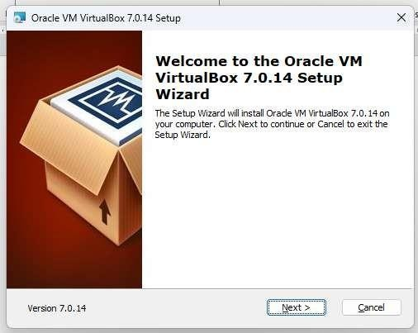

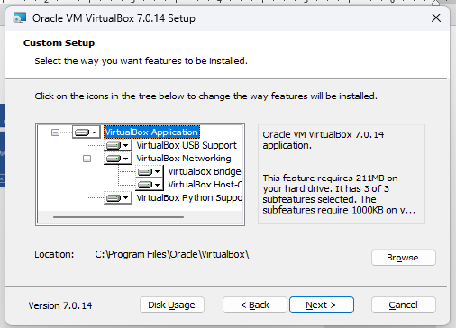

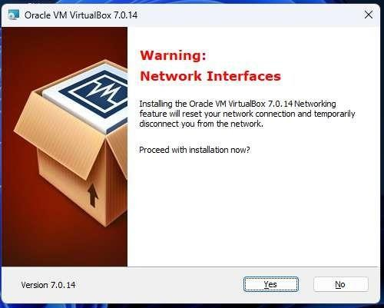

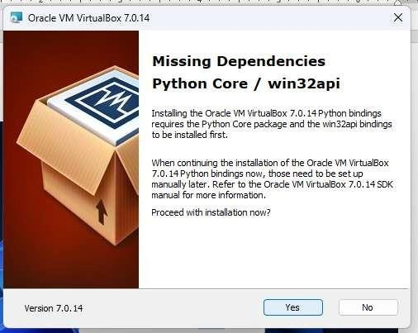

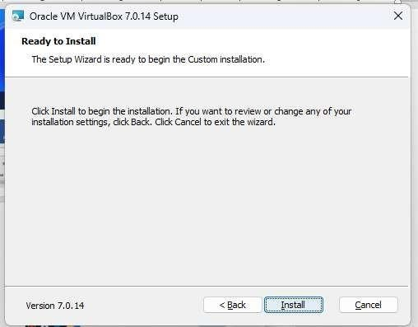

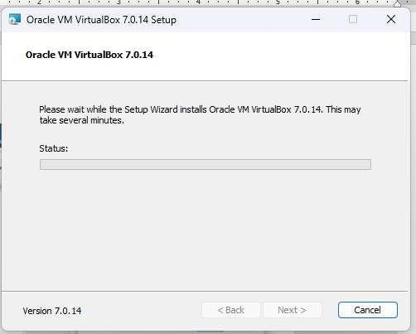

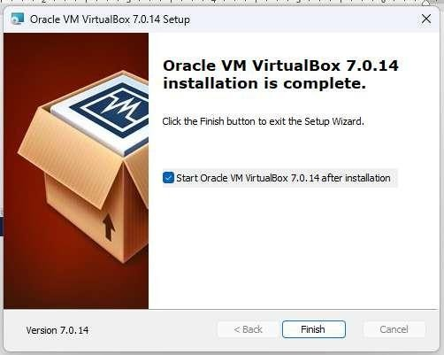

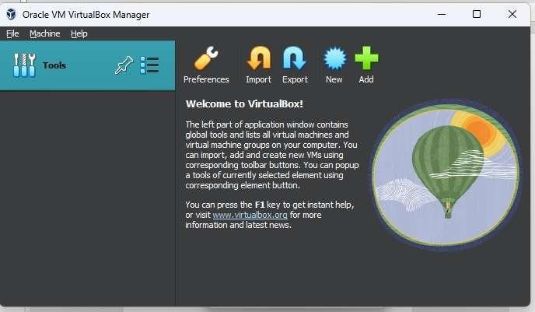

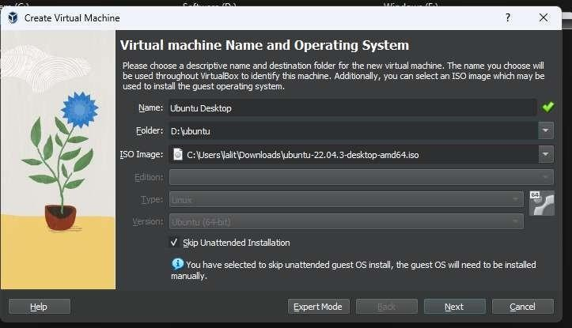

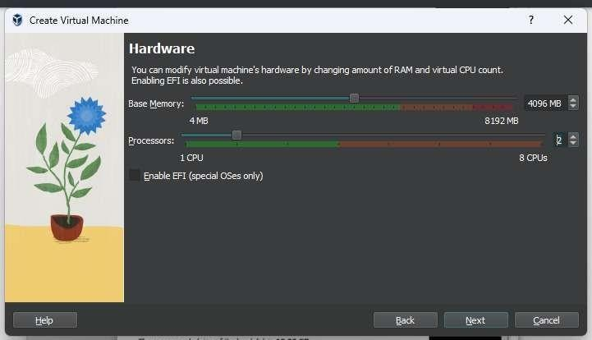‘

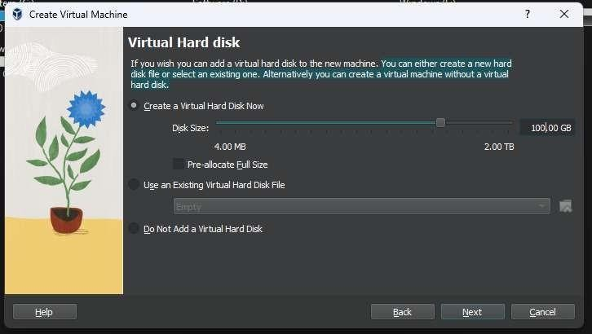

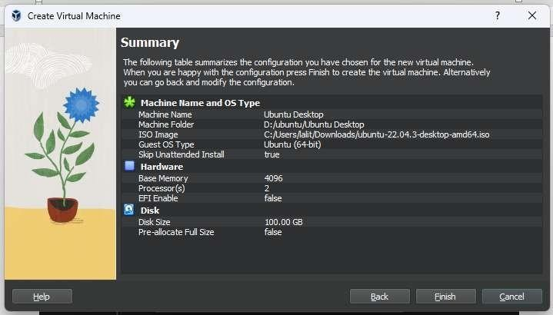

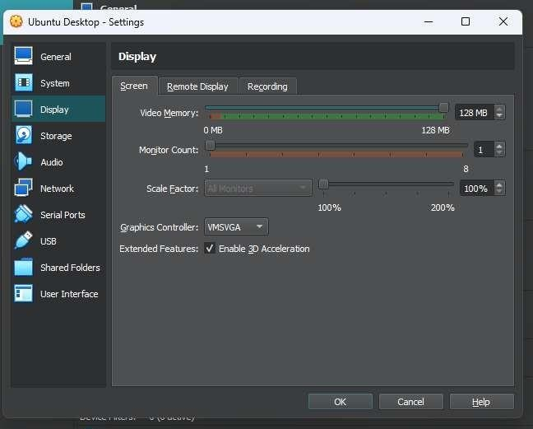

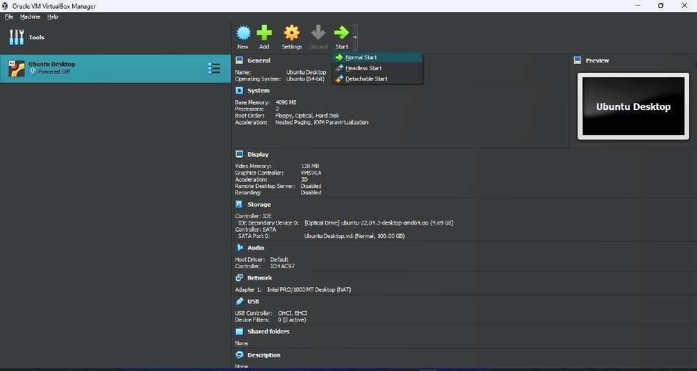

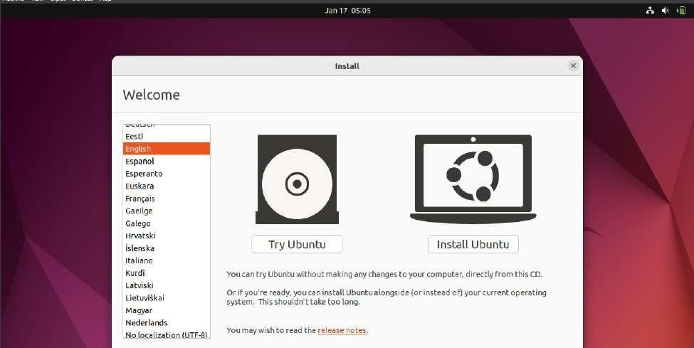

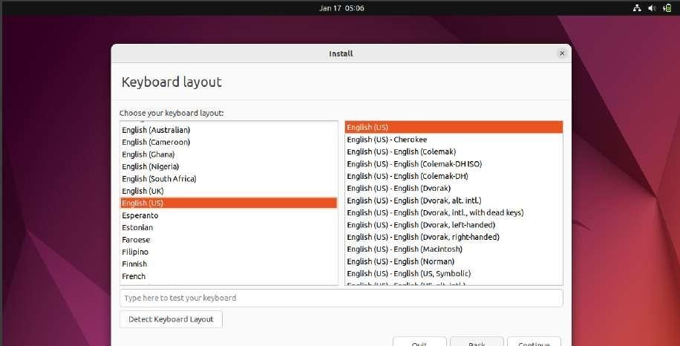

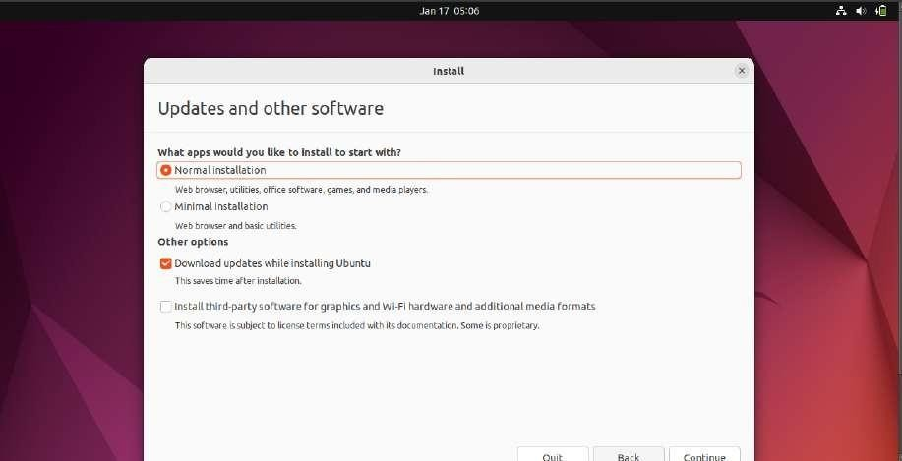

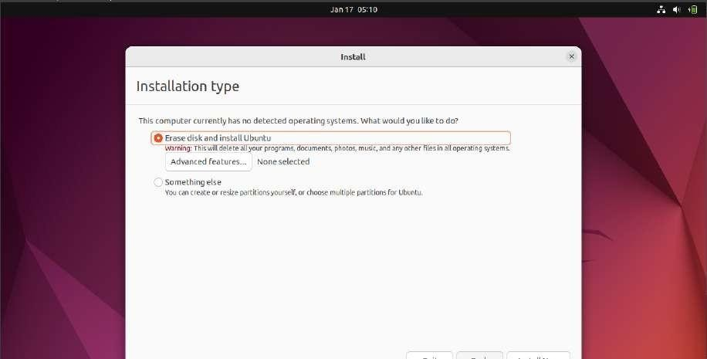

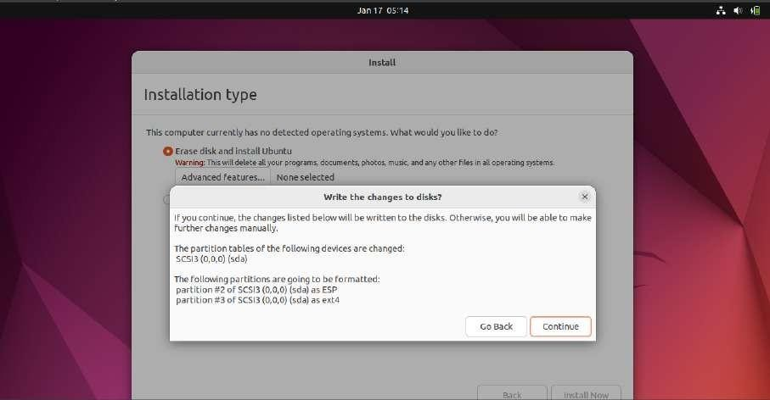

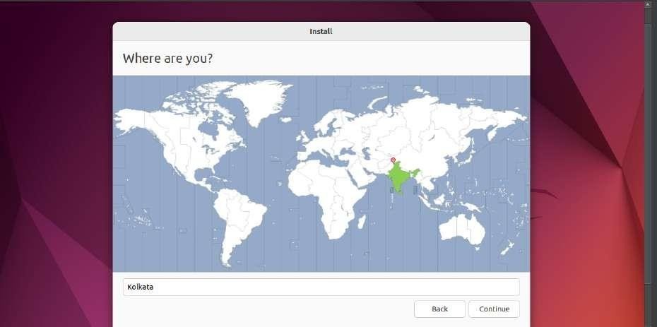

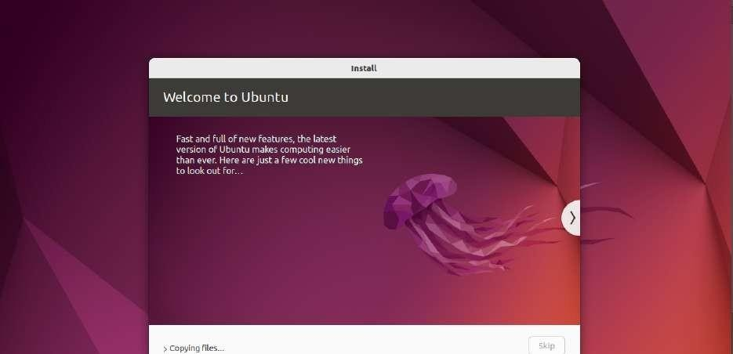

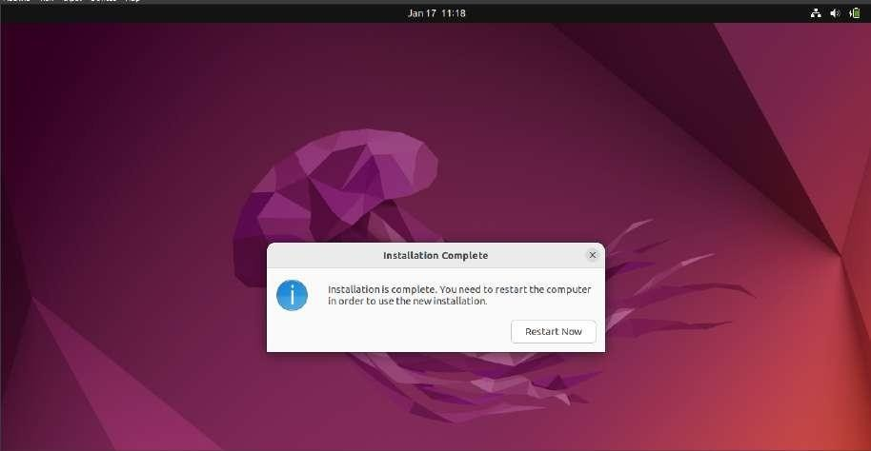

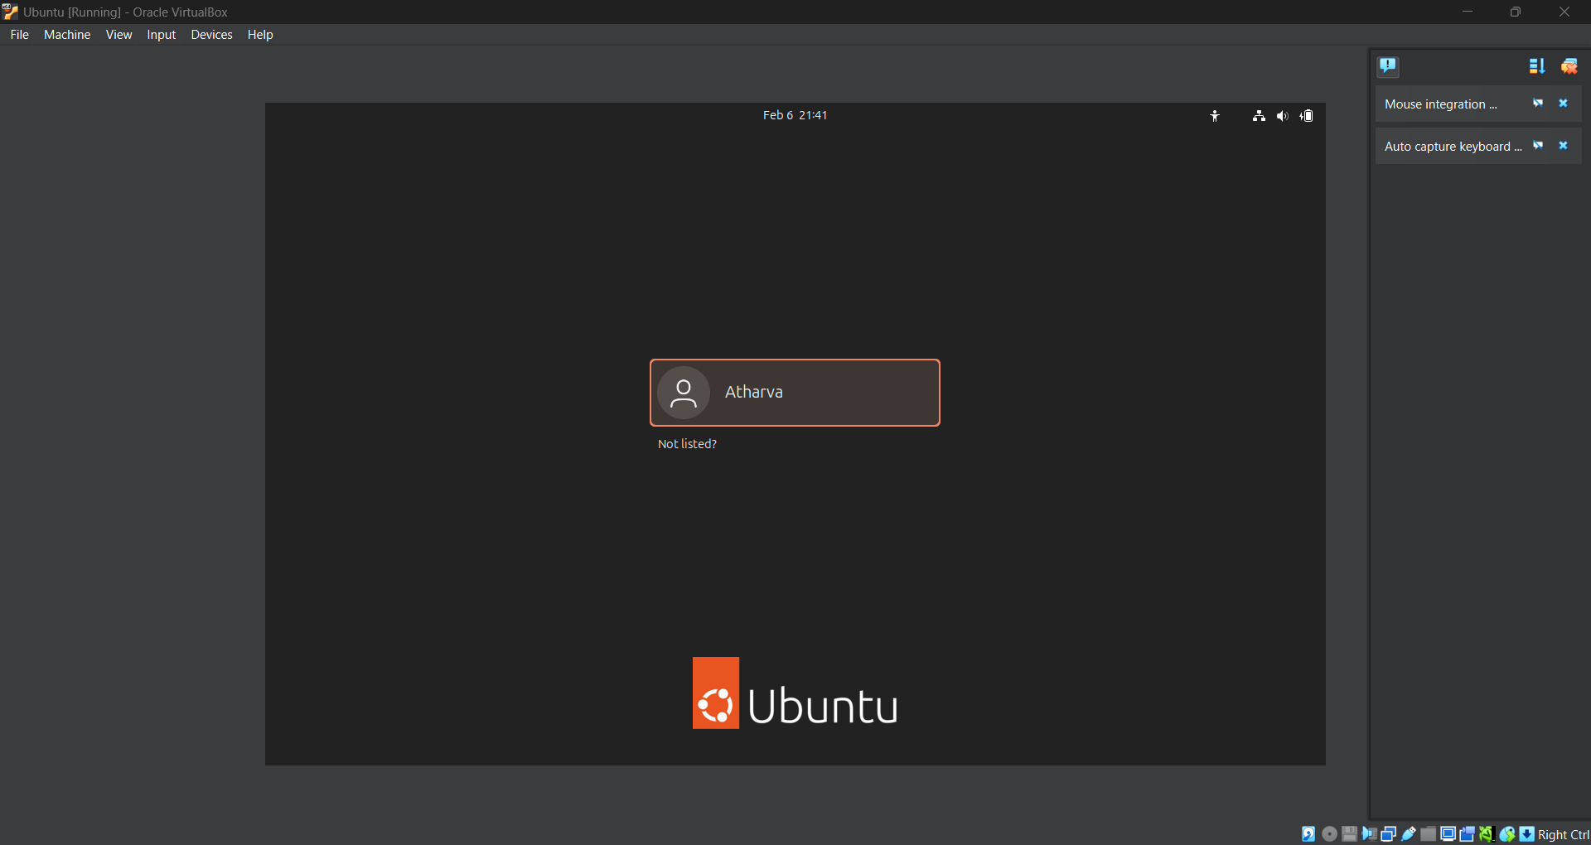

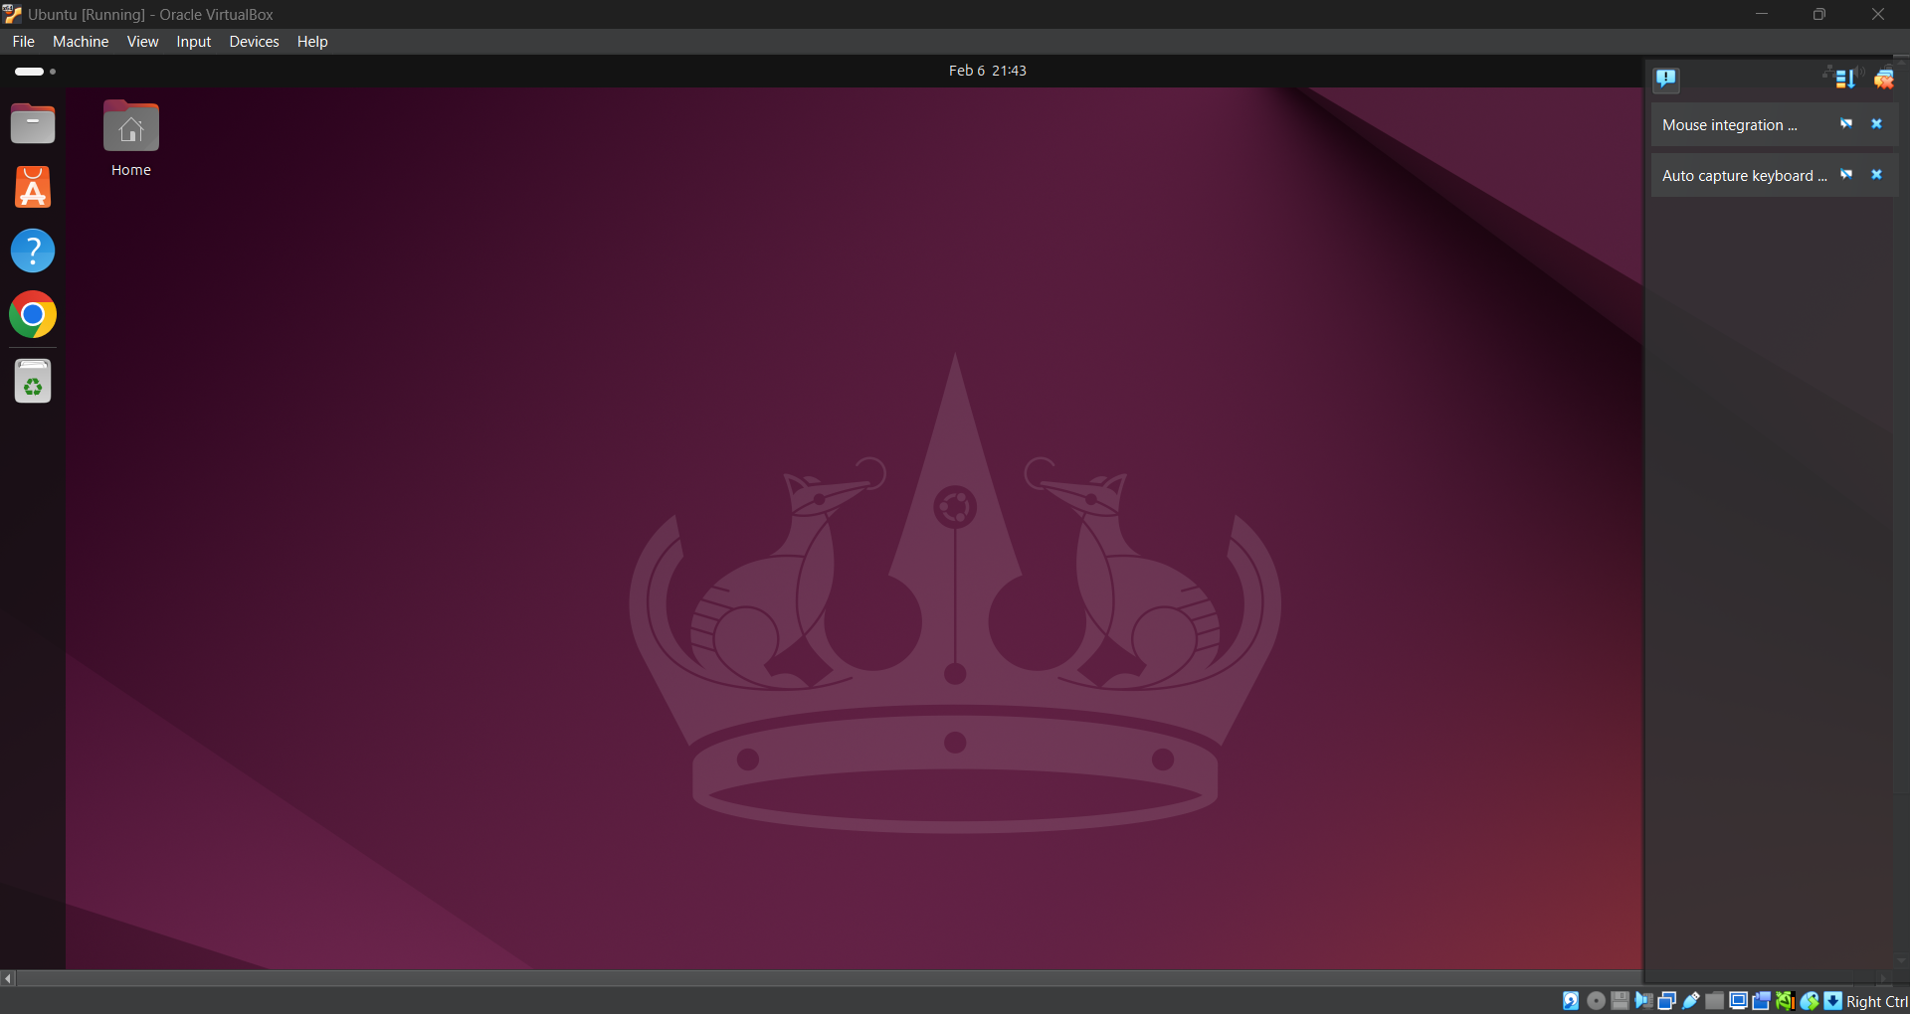

**To run commands in CL**

**Pwd**: shows the present working directory

**Ls**: lists all the contents in pwd.

**cd**: stands for change directory & mkdir: stands for make directory

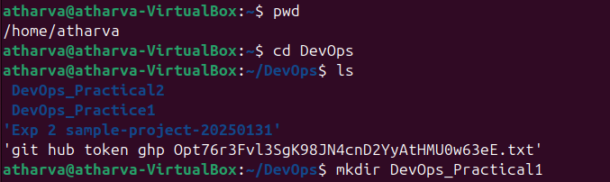

**Rmdir**: stands for remove directory

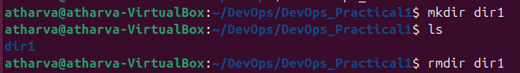

**cat** : it is used to view the contents of a file in the terminal window itself

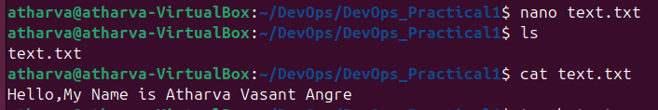

**Touch** : creates a file in pwd with the given filename.

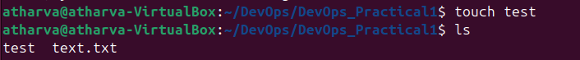

**cp**: copies the contents of one file to another.

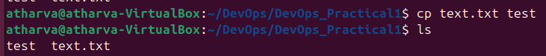



**echo**: used to display any text on the CLI.



**Hostname**: displays the hostname of the machine



**Ping**: it is used to ping any ip address of choice

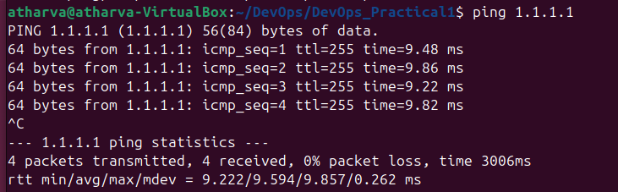

**ln & ln -s:** used to create hard links and soft links respectively

**ls -ltr**: lists all the files and directories with all the properties.

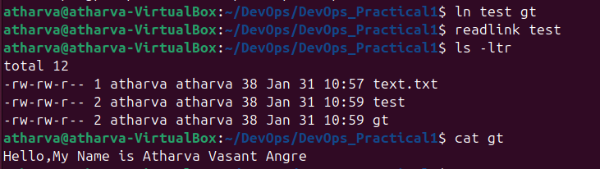

Here you can see the content of the hardlink “gt” which was created previously

**Grep**: it is used to search specific texts in a file



here echo is combined with the **tee** command to insert the echo message in the hardlink file

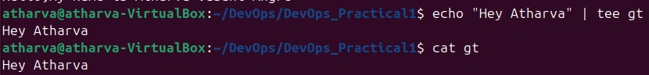

As you can see, the contents of the the file Githubtoken has been changed too as it’s hardlink “gt” was changed

**Wc**: is used to show the word count of a file

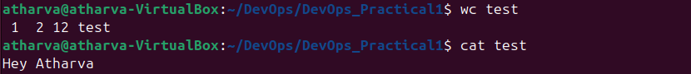

Here we create a file using the **touch** command and then we use the **nano** text editor to edit the contents of the file.

The **sort** command is used to sort the contents of the file in alphabetical order

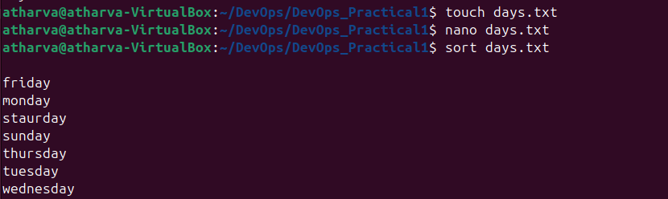

The **gzip** command is used to create a zip of any file



The **gzip -dv** is used to decompress the zip file

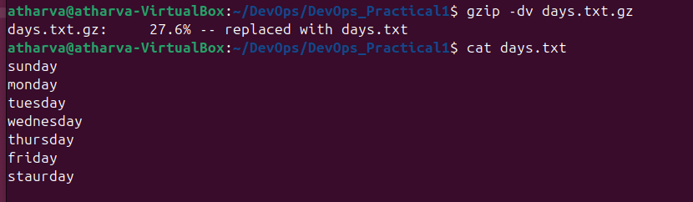

The **awk** command is used a filter where we can specify which words and contents of the file do we wish to retrieve

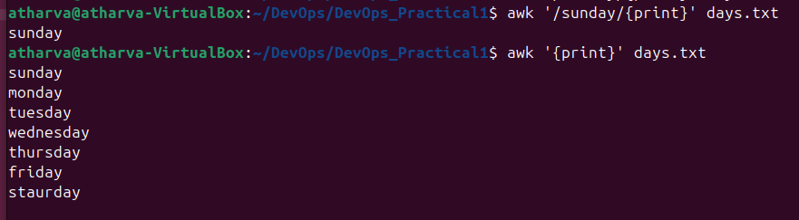

The **systemctl** command is used to show all the running process in the system, the same can be done with **htop** as well.

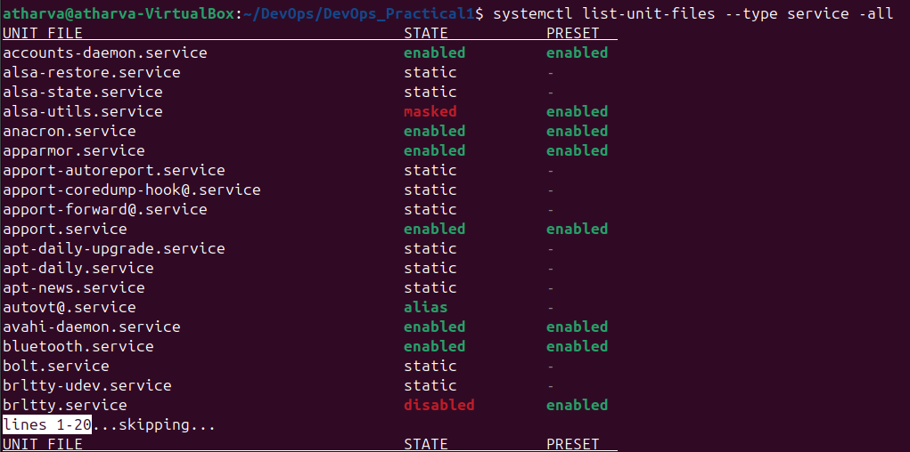

Here we use the **grep** command to filter out running processes.

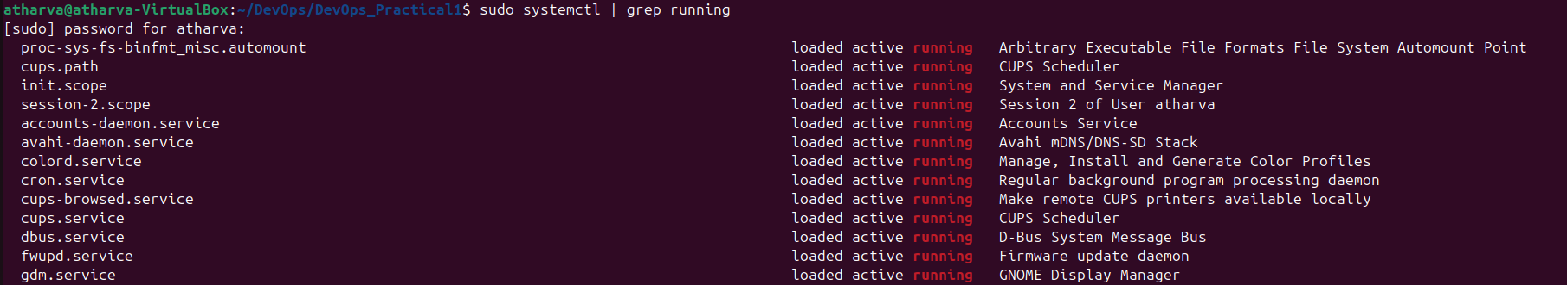

We use the **top** command to show the list of all processes, and we can identify the process ID using this command

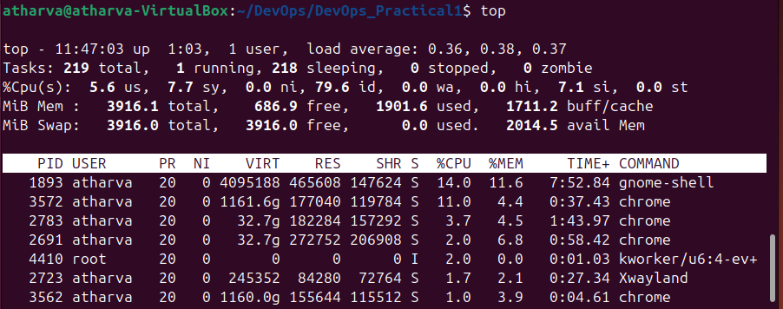

Once we identify the process we want to kill, we can use the command **sudo kill PID**, to kill the process successfully.

Processes can be killed using their name too



**File structure of linux**:

The file system in Linux follows a hierarchical structure, and it is a key component of the operating system that organizes and stores data. Here's a brief overview of the main directories and their purposes in the Linux file system:

**1. / (Root Directory):**  The top-level directory and the starting point for the entire file system.

**2. /bin (Binary Binaries):**  Contains essential binary executables that are required for the system to function in single-user mode.

**3. /boot:** Contains the Linux kernel, initial ramdisk, and other files necessary for the system boot process.

**4. /dev (Device)**: Contains device files representing hardware devices in the system.

**5. /etc (Etcetera):**  Houses system-wide configuration files and startup scripts.

**6. /home:**  Home directories for user accounts are located here.

**7. /lib (Library):** Essential shared libraries needed by system binaries are stored in this directory.

**8. /media:** Mount points for removable media devices, such as USB drives.

**9. /mnt (Mount):**  Mount points for temporary mounts by the system administrator.

**10. /opt (Optional):** Typically used for installing third-party software or additional packages.

**11. /proc (Process):**  A virtual file system that provides information about running processes and system status.

**12. /root:**  The home directory for the root user.

**13. /run:**  A directory for system runtime data, often used by system services.

**14. /sbin (System Binaries):**  Contains system administration binaries, usually reserved for root.

**15. /srv (Service):** Data for services provided by the system.

**16. /tmp (Temporary):**  Used for temporary files that may be deleted between system reboots. **17. /usr (User):**  Secondary hierarchy for read-only user data and programs.

**18. /var (Variable):**  Variable files such as log files, spool files, and temporary files.

The lsblk -f can be used to view the file system in CLI.

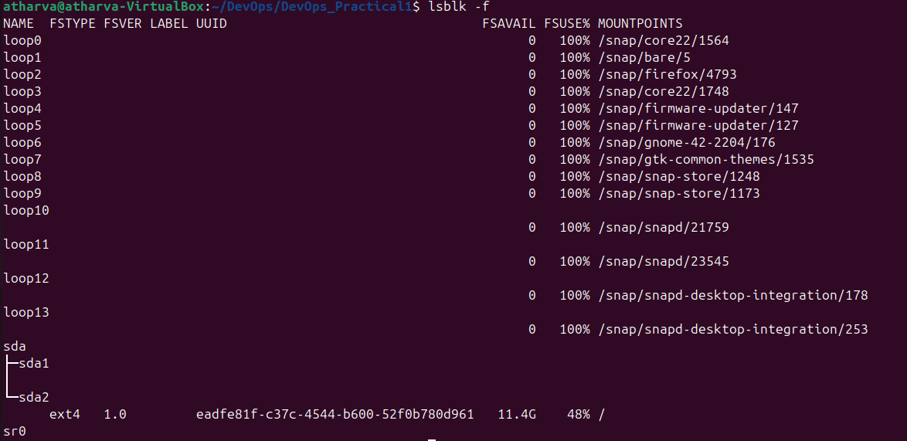

Same can be done using the command df -Th

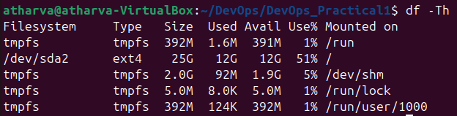

**Conclusion**: In this practical, we see how we can install ubuntu on our systems, we also find out how to use various types of basic, filter, text editor commands and their use cases. Lastly we find out about the file system of linux and how we can view the same in the CLI